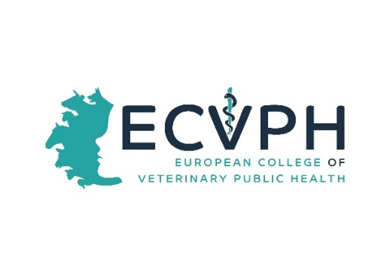

_________________________________________________________________

CALL FOR CONFERENCE WORKSHOP PROPOSALS
Dear Colleagues, 23. May 2023
For this Years´s Annual Scientific Conference and Annual General Meeting of the ECVPH which will be held as a HYBRID-event on 20-22. September 2023 (in BERLIN and online!), we are organizing a Conference under the tentative theme „Veterinary public health challenges at the farm animal – wildlife – environment interface”. The Conference aims to feature three parallel workshops (2 hrs) on Thursday 21. September 2023 that are intended to once more provide a forum for researchers, policy makers and practitioners in Veterinary Public Health to discuss and exchange positions on current issues related to VPH. Workshop attendants will exchange ideas and experience, establish common ground in research areas or practical problems. We would again like to invite our Diplomates and Residents to submit workshop proposals. This would be an opportunity to recognize expertise that we have within our College and hopefully identify new opportunities for collaboration and future activities. The workshop offered by the Diplomates and/or Residents that have been selected will be scheduled in the Conference program.
Submission format (please compile the form attached)
Workshop proposal must include:
- A concise title.
- The names and affiliations of the organizers
- A statement detailing: Why is the workshop topic important? Why is the workshop timely? How is it relevant to the topic of the Conference?
- A two-paragraph description of the workshop topic and didactic concept
- A short bio of the workshop organizers, including a description of their qualifications relative to the workshop topic
Important dates
- Workshop proposal submission deadline: 16th June 2023 !
- Acceptance notification: 30th. June, 2023
- Workshop date: September 21st, 2023 from 13:45 – 15:45 (2 hours)
Please send your proposal described in the below form to: ecvphdocsec@gmail.com

Thanking in advance for your kind co-operation and looking forward to receiving your proposals,
with best regards,

Len J.A. Lipman, ECVPH President

YOUR PROPOSAL
Title of Proposal

A concise title.
Contact Organizer
Salutation/title First name Surname

Affiliation (no abbreviations)

Email Phone

Address Line 1

Address Line 2

City and Postal Code Country

Please provide short bio of the workshop organizers, including a description of their qualifications relative to the workshop topic

Objectives
A statement of the objectives of the workshop and indication of its relevance, importance and timeliness

• A statement detailing: Why is the workshop topic important? Why is the workshop timely?

Description of the workshop topic and didactical concept.
Please provide a two paragraph description

