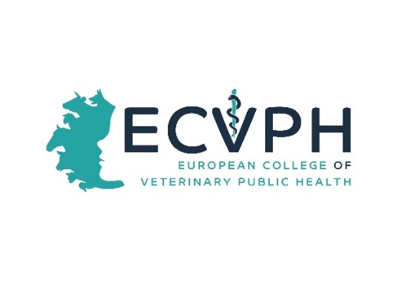

_________________________________________________________________

CALL FOR CONFERENCE WORKSHOP PROPOSALS
Dear Colleagues, 13. May 2021
For this Years´s Annual Scientific Conference and Annual General Meeting of the ECVPH which will again be held ONLINE on 23-24. September 2021, we are organizing a Conference under the tentative theme “Transforming food systems: A new era for VPH". The Conference aims to feature three parallel workshops (2 hrs) on Thursday 23. September 2021 that are intended to once more provide a forum for researchers, policy makers and practitioners in Veterinary Public Health to discuss and exchange positions on current issues related to the this topic. Workshop attendants will exchange ideas and experience, establish common ground in research areas or practical problems. We would again like to invite our Diplomates and the Residents to submit workshop proposals. This would be an opportunity to recognize expertise that we have within our College and hopefully identify new opportunities for collaboration and future activities. The workshop offered by the Diplomates and/or Residents that have been selected will be scheduled in the Conference program.
Submission format (please compile the form attached)
Workshop proposal must include:
- A concise title.
- The names and affiliations of the organizers
- A statement detailing: Why is the workshop topic important? Why is the workshop timely? How is it relevant to topic of the Conference?
- A two-paragraph description of the workshop topic and themes
- A short bio of the workshop organizers, including a description of their qualifications relative to the topic area
Important dates
- Workshop proposal extended submission deadline: 15th June 2021 !
- Acceptance notification: 20. June, 2021
- Workshop date: September 23th , 2020 from 14:00 to 16:00 (2 hours)
Please send your proposal described in the below form to: ecvphdocsec@gmail.com

Thanking in advance for your kind co-operation and looking forward to receiving your proposals,
with best regards,

Lisa Boden, ECVPH President

YOUR PROPOSAL
Title of Proposal

A concise title.
Contact Organizer
Salutation/title First name Surname

Affiliation (no abbreviations)

Email Phone

Address Line 1

Address Line 2

City and Postal Code Country

Please provide short bio of the workshop organizers, including a description of their qualifications relative to the topic area

Objectives
A statement of the objectives of the workshop and indication of its relevance, importance and timeliness

• A statement detailing: Why is the workshop topic important? Why is the workshop timely?

Description of the workshop topic and themes
Please provide a two paragraph description

